

**You are kindly invited to attend our Parish Ecumenical Service commemorating the 500th anniversary of Luther’s Reformation. It will be held on Thursday 16th November at 7.30 pm in Ss. Peter & Paul Church, Crecora. Rev Liz Beasley from Adare will preach at the service and we will be joined by members of the Church of Ireland Community from the region and the parish choir will sing.**

**Refreshments will be served afterwards in the school hall.**

**[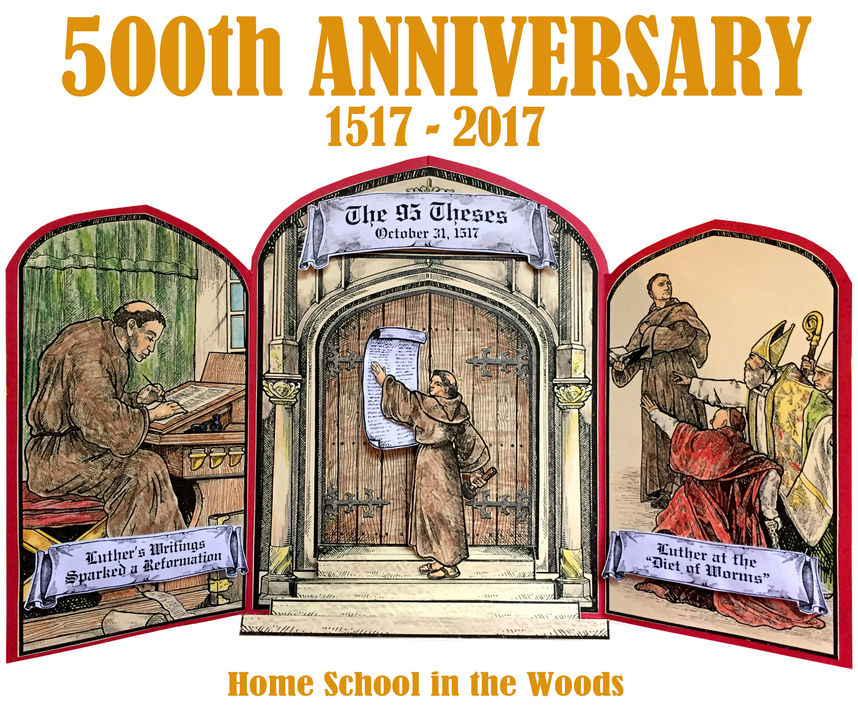](https://www.google.ie/url?sa=i&rct=j&q=&esrc=s&source=images&cd=&cad=rja&uact=8&ved=0ahUKEwjTh7-AvazXAhVhAcAKHZ-PAZkQjRwIBw&url=https://www.pinterest.com/pin/412501647104770531/&psig=AOvVaw0njWGjyB4-KBflvpOiPKCH&ust=1510144550059701)**

**Candlelight Mass for the Deceased**

Today is **Mission Sunday** and the Holy Father invites all Catholics to contribute to a special collection. Every person in every parish in every country where the Church is present will be celebrating together and sharing what they have, no matter how little. It is the one Sunday in the year when the Mass is celebrated exclusively for missionary activity. Donations are collected at these worldwide Masses and they go to support churches, hospitals, schools and vocations in countries where the Church is new, young or poor. It is also the one Sunday in the year when your generosity goes directly to help mission parishes overseas and reach out with Jesus’ message of hope and love. World Missions Ireland is the Holy Father’s official charity for overseas mission. It is responsible for coordinating Mission Sunday in Ireland and, through local bishops, churches, and missionary congregations around the world ensures that resources are distributed equitably and justly on the basis of need. In offering our prayers, we join with missionaries everywhere in communion and compassion to support them in spreading the Good News, and by giving a donation we respond to Christ's call to feed the hungry and clothe the naked so please give what you can. Thank You.

**Thirty-Second Sunday in Ordinary Time.** 12th November, 2017

1st. May, 2016

[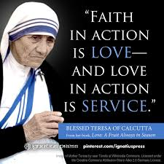](https://www.google.ie/imgres?imgurl=https://s-media-cache-ak0.pinimg.com/736x/6f/ee/f5/6feef5f09a851cd0f6f44ca7947dd310.jpg&imgrefurl=https://www.pinterest.com/explore/mother-teresa-books/&docid=7-q1MKGuSTCzRM&tbnid=18qaU6vWShOtXM:&vet=10ahUKEwjkyYj3vf7SAhXjDMAKHQfZBXcQMwghKAAwAA..i&w=736&h=736&bih=744&biw=1440&q=free%20catholic%20clip%20art%20mother%20teresa&ved=0ahUKEwjkyYj3vf7SAhXjDMAKHQfZBXcQMwghKAAwAA&iact=mrc&uact=8)

**Fr. John O’Shea P.P.**  The Presbytery, Raheen • 087 9708282

**Fr. Richard Davern,** Ballyduane, Clarina • 087-2977500 • 061 353529

**Fr. Robin Thomas**, “St. Joseph’s”, Lifford Avenue. 089-4333124

**Mary Egan, Parish Secretary** • 061 210869 • 10am - 4pm

**• e-mail: parishoffice@mcrparish.com**



**Candlelight Mass for the Deceased: Raheen: 15th. November 7.30 p.m.**

**Mass will be celebrated both nights to remember our beloved deceased. At the Masses, the names of those whose funeral Masses were celebrated in our church in the last 12 months will be called out. A candle will be on the altar and a family member is invited to come forward to light their loved one’s candle. After those candles are lit, there will be an opportunity for anyone else present who had a bereavement during the year, but whose funeral was not celebrated in our church, to bring forward a small candle which will be supplied at the back of the church.**

**An Ecumenical Service will be held at the Catholic Church of Ss. Peter & Paul, Crecora on Thursday 16th November at 7.30 p.m. *See front page*.**

**On December 8th, the Feast of the Immaculate Conception, a consecration of Ireland to the Immaculate Heart of Mary will take place. This is a wonderful opportunity to join with hundreds of thousands of other Irish people in entrusting ourselves and our country to Our Lady. Fr Michael Gaitley, a priest of the Marians of the Immaculate Conception (MIC), has published a bestselling book titled 33 Days to Morning Glory. The Book contains short daily readings based on the devotion of 4 exemplary Saints known as much as anything for their Marian devotion; St Louis Marie de Montfort, St Maximilian Kolbe, St Teresa of Calcutta, and St John Paul II. He has donated hundreds of thousands of these books which are being distributed in magazine form to parishes around Ireland. Using these booklets preparation for consecration to Jesus through Mary will begin around the country on November 5th with aim to consecrate oneself on December 8th, the Feast of the Immaculate Conception, in this year, the 100th anniversary of the Fatima Apparitions. Whatever your path through life, allow yourself to walk the way with the one who understands its challenges best.**

**See** [www.timeofmercy.ie](http://www.timeofmercy.ie)

**33 Days to Morning Glory Booklet available at the back of the church.**

**“World Day of the Poor”. Pope Francis has inaugurated a “World Day of the Poor”. The First celebration of that Day occurs next Sunday, November 19th. Pope Francis wants us already this coming week to reach out to the Poor around us. He writes, “It is my wish that, in the week preceding the World Day of the Poor, which falls this year on 19 November, the Thirty-third Sunday of Ordinary Time, Christian communities will make every effort to create moments of encounter and friendship, solidarity and concrete assistance.”**

**Knitivity: Thanks to all who got involved in the Knitivity for Beaumont Hospital, if you could please have your knitting into us by the weekend of the 25th/26th November. You can drop them to the Sacristy or to the Parish Office.**

**Thomond Flower & Garden Club will hold their Christmas Floral Demonstration at the South Court Hotel, Raheen, Wednesday Nov.15th at 8 p.m.**

**Margaret Ahearn (AOIFA) will create floral arrangements with a theme “Joy to the World”. This great opportunity to get tips and suggestions for the Christmas. New members and visitors welcome. Enquiries 087-9006333.**

**Milford Care Mentre for all those remembered on the Light Up a Memory Tree.l**

**The Joy of Love in Marriage:A Marriage Encounter Weekend offers married couples (of all age ranges) private time to rediscover the joy of their love. The next Residential Weekend will be from 17 to 19-Nov- The Lake Hotel, Killarney. visit www.marriageencounter.ie or call (086) 6095168 or 064 6644319**



**Mass Times 11th/12th November..**

Vigil 6 pm Noel Nagle & Deceased family

members (A)

**also** Ted Cusack (Months Mind)

11. a.m. Johnny Stapleton (1st. A)

12.30 pm. Mary O’Riordan (Months Mind)

**Mungret:**

**Sunday:** Damien Coughlan (A)

**Crecora:**

Sunday: Michael Fitzgerald & Joe Conway(A)

**Week ahead 13th – 17th Nov. Raheen**

Mon: Pro Pop.

Tue: Ann Heffernan (A)

Wed: Kathleen, John, Bridie Naughton

7.30 Candlelight Mass for the Deceased

Thurs:

Friday: Purgatorial

**Raheen: Weekend 18th – 19th Nov.**

6 p.m. Jack & Lily Egan (A).

**also**  Bunty Phelan (A)

11 a.m. May Byrnes (A)

12.30 p.m. Eugene Younger (A))

**Crecora: Daniel, Eileen & Michael Mann (A)**

**Mungret:**

**Saturday: Edward Grimes (A)**

**Diocesan Needs Collection: Second Collection at all Masses next weekend.**

**Lemonfield: Sunday, Nov.12th at 2.30 p.m.**

**Crecora new and old Cemeteries:**

**Sunday, November 12th at 3 p.m.**

**Raheen Remembrance Tree for month of November: You may like to put the names of your deceased relatives and friends on the cards provided and place them on the tree. They will be remembered in prayers during this month.**

**Mungret St. Paul’s G.A.A. Camogie and Ladies Football Club invite all to an open meeting on Thursday 16th November at 7.45 p.m. in G.A.A. Community Centre, where plans for the next few years will be discussed.**

**Santa Letter Programme 2017: Would you like to be Santa to a child this Christmas from a school in Limerick which is designated with underprivileged status. If you would like to sign-up, you will receive a “Santa Letter” from a child. Please put your name and contact number on the sheet provided at the back of the church.**

**MASS TIMES IN THE PARISH :**

**Raheen: Vigil 6pm Sun 11am & 12.30 pm** Mon – Fri 10 a.m. Eucharistic Adoration 10.30am–10 pm

**Crecora:** .**Sunday** **10 a.m**. Tue. – Wed - Thurs 9.15 a.m. **Eucharistic Adoration:** Thurs 10 – 11 a.m. 6p.m. - 10 pm

**Mungret: Sunday** **11.30 a.m**. Wed & Fri 9.30a.m. **Sat** 11.30 a.m. **Eucharistic Adoration:** Wed 10am–12 noon.

***Come Holy Spirit [](http://www.google.ie/url?sa=i&rct=j&q=&esrc=s&source=images&cd=&cad=rja&uact=8&ved=0ahUKEwiegLDVqsnSAhWnLsAKHb1qDlQQjRwIBw&url=http://www.clipartpanda.com/categories/holy-spirit-dove-clipart-black-and-white&psig=AFQjCNFptrxvNvIrlceTdi82JVIndABu_A&ust=1489145833113380)***